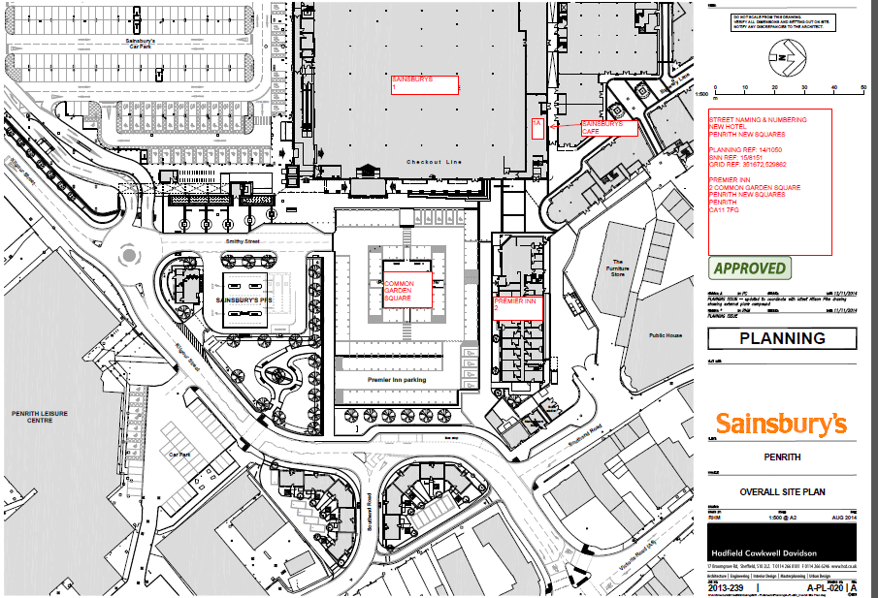
158151 Common Garden Square Development Plan

